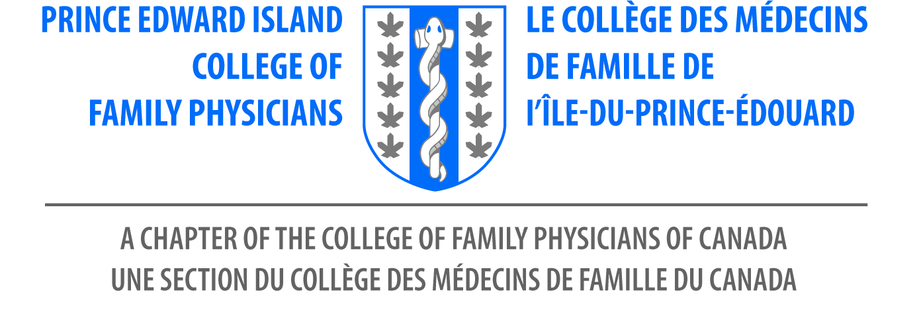

^{7th} Annual Family Medicine Conference
Mark your Calendars! June 9, 2023

Delta Prince Edward, Charlottetown, PE
Supported by the Prince Edward Island College of Family Physicians

Join PEICFP for the 7th Annual Family Medicine Conference in Charlottetown PEI. Our Planning committee prepared a fabulous day of education and a hall of informative exhibits. Awards luncheon will be offered and much more!

Please download this form if you wish to register by cheque: Make cheques payable to FMC PEICFP 2023

Personal Information

First Name_______________________________________________

Last Name: ______________________________________________

Email Address: ___________________________________________

Address: ________________________________________________

City: ___________________________________________________

Province: _______________________________________________

Any dietary needs? Type | Fee (Taxes included)
CFPC Member | $185.00 CAD
Resident | $75.00 CAD
Non- Member/ NP/Gov. org. | $200.00 CAD
Medical Student | $30.00
Honorary. guest | No Charge
Exhibit Booth | $800.00 CAD

Contact, Rose Burke-Perry for assistance.
rbperry@peicfp.ca
902393-2702

PEICFP
CPD Planning Committee

