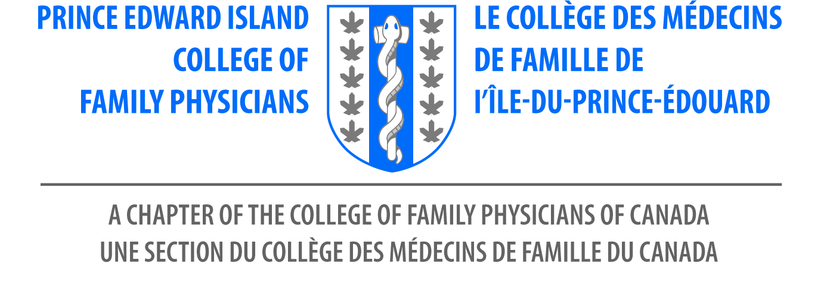

6th Family Medicine Conference
Mark your Calendars! June 17, 20202

Delta Prince Edward, Charlottetown, PE
Supported by the Prince Edward Island College of Family Physicians

Join PEICFP for the 6th Annual Family Medicine Conference in Charlottetown PEI. Our Planning committee prepared a fabulous day of education and a hall of informative exhibits. Awards luncheon will be offered and much more!

Please download this form if you wish to register by cheque: Make cheques payable to FMC PEICFP 2022

Personal Information

First Name_______________________________________________

Last Name: ______________________________________________

Email Address: ___________________________________________

Address: ________________________________________________

City: ___________________________________________________

Province: _______________________________________________

Any dietary needs? ______________________ Type | Fee (Taxes included)
CFPC Member | $175.00 CAD
Resident | $75.00 CAD
Non- Member/ NP/Gov. org. | $200.00 CAD
Medical Student | $30.00
Honorary. guest | No Charge
Exhibit Booth | $800.00 CAD

Contact chapter administrator, Rose for further assistance.
rbperry@peicfp.ca

Thank you
PEICFP

