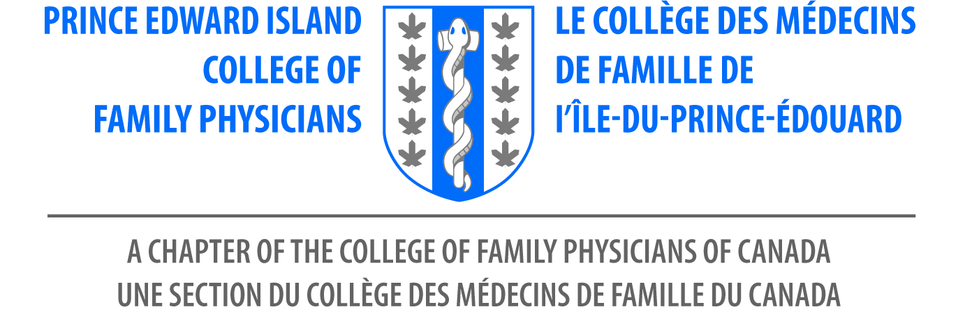

Canada
Province of Prince Edward Island
A Proclamation

WHEREAS family physicians are a resource to their communities, collectively leading the delivery of accessible, comprehensive, continuity-based, patient-centred care, and

WHEREAS the patient-doctor relationship is central to the care provided by family physicians, which extends over time and across all ages, life stages, domains and settings as required to meet patient needs, and

WHEREAS family physicians are highly skilled generalists and bring a unique orientation and skill set, strengthening the compassion, comprehensiveness, cohesion, capacity and overall quality of the health care system, and

WHEREAS collectively, the care provided by family physicians improves the overall health of the population, and

Whereas we celebrate this day together with family physicians across the world to recognize the progress being made in family medicine and the special contributions of family doctors in Prince Edward Island and globally;

NOW KNOW YE THAT, We do by the presents proclaim and declare the May 18, 2018 shall be known as

“Family Doctor Day”

In the Province of Prince Edward Island.

_____________________________ __________________________
Minister of Health and Wellness President Elect CFPPEI
Robert Mitchell Dr. Kristy Newson

