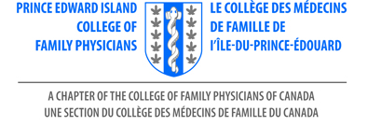

Family Medicine Conference (FMC)
Virtual
Mark your Calendars! June 11, 2021

Supported by the Prince Edward Island College of Family Physicians
Online registration now open: 5th Annual Family Medicine Conference
Join our PEICFP for 5th Annual Family Medicine Conference. Our Planning committee prepared an extraordinary day of education.
Please download this form if you wish to register by cheque: Make cheques payable to FMC PEICFP

Required information

Personal Information
First Name_______________________________

Last Name: ______________________________

Email Address: ___________________________

Address: ________________________________

City: ___________________________________

Province________________________________

Fee
CFPC Member $55
Non-Member $65
Resident 0
Medical students
Physician studies 0
Payment Method
• Pay with PayPal or Credit Card, online: 5th Annual Family Medicine Conference
• Pay with Cheque please use this form.

College of Family Physicians - PEI, 253 King St., Charlottetown, Prince Edward Island C1A 1C4, Canada
Contact for conference information
Rosemary Burke Perry: rbperry@peicfp.ca

